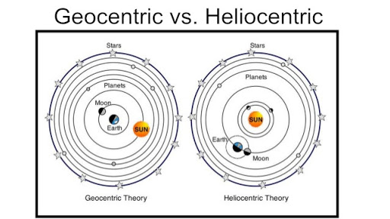
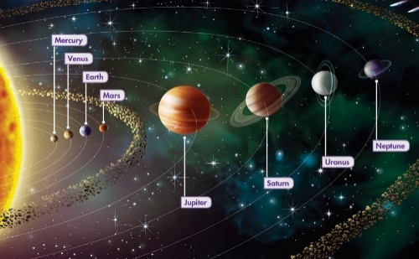
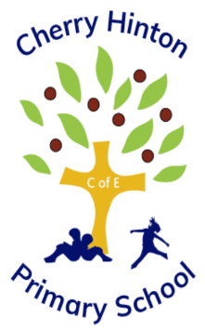
What I will learn next.
1 | Y6 Evolution and Inheritance | Evolution, how humans have changed.

What I have learnt already.
1 | Y5 - Life in the 1960s. | Space race -the first human in space and on the moon.

Facts I need to learn now.
1 | Geocentric vs Heliocentric models | Many years ago, people believed that the Sun and planets orbited the Earth: the geocentric model. It was suggested by astronomers such as Ptolemy, Aristotle and Alhazen. Over time, the heliocentric model was developed by astronomers such as Copernicus, Galileo and Kepler with the Earth and planets recognised as orbiting the sun.
2 | Day and night | The Earth rotates on its axis every 24 hours. At the same time, it is also orbiting the sun (a full orbit takes 365 ¼ days). Daytime occurs when the side of the Earth is facing the sun and night time occurs when it is facing away.
3 | Moon | orbits the Earth in an oval shaped path. At different times of the month, the moon appears to be different shapes as the sun lights up different parts of it.
4 | Collection: water returns to the sea | Rain water runs over the land and collects in lakes or rivers, which take it back to the sea. The cycle starts all over again.
5 | Uses of the Rivers. | Water, food, leisure, transport, energy and factories.

Vocabulary (Words I need to know).
1 | sun | A huge star that the Earth and other planets in our solar system orbit around.
2 | star | A giant ball of gas held together by its own gravity.
3 | planet | A large spherical object that orbits around a star.
4 | moon | A natural satellite that orbits the Earth or another planet.
5 | solar system | The sun and all the other objects that orbit it: planets, moons, asteroids, meteors, etc.
6 | universe | All existing matter and space together.
7 | sphere | A round 3D shape in the shape of a ball.
8 | orbit | Moving in a regular, repeating curved path around another object.
9 | satellite | Any object that orbits another object e.g. the moon is a satellite of Earth.
10 | axis | An imaginary line that something rotates around e.g. Earth’s axis run’s through the middle of the planet, from the North Pole to the South Pole.
11 | Deposition | When the river drops some of the material (sediment) it is carrying.
12 | Sediment | Solid materials carried in water, like stones and sand.

Flood Plain | Flat land beside a river that is likely to flood. | Flood Plain
Delta | An area of land formed when sediments carried by a river build up. | Delta

A diagram to help me understand.
How does the solar system work?

Science
Inquisitive Thinkers • Inspired Learners • Kind hearts
Agape
Courage
Thankfulness
Year 6 Knowledge Organiser

