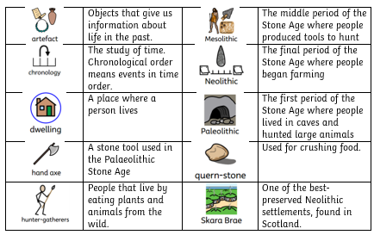

Vocabulary (Words I need to know)

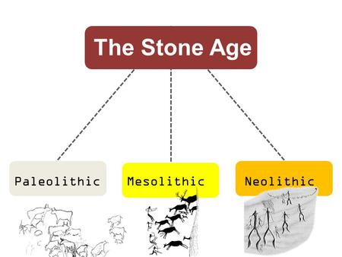
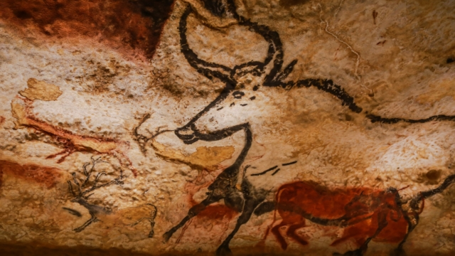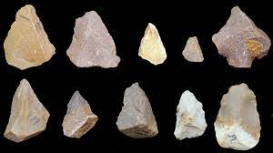
Facts I need to learn now
1 | Stone Age chronology | The Stone Age can be split into:  1. Palaeolithic – climate change. People ate mammoths and reindeer, and foraged for foods.  2. Mesolithic – hunter gatherers. People used tools like bow and arrows to hunt smaller prey.  3. Neolithic – early farmers. Sheep and goats were kept as animals and people started to make pottery.
2 | Homes | Stone Age people did not live in homes like ours. Instead they lived in caves or small circular structures made from wooden posts.
3 | Animals | Stone age animals included woolly mammoths, reindeer and woolly rhinoceroses!
4 | Tools | During the Mesolithic era, people began to make tools such as hand-axes to help them hunt for food. Weapons were made from bone, ivory, wood, antlers, stone or flint.
5 | Food | Towards the end of the Stone Age, there was a move towards farming. People began to keep sheep and goats rather than hunt larger animals.

Inquisitive Thinkers • Inspired Learners • Kind hearts
Agape
Courage
Thankfulness
Topic Question: Who were the first Britons?

History
Year 3 Knowledge Organiser

