
Facts I need to learn now
1 | The Great Fire of London | The fire started in a bakery on Pudding Lane.
2 | The Great Fire of London | The Great Fire of London happened between the 2nd and the 5th of September 1666.
3 | Houses | Many houses were made from wood and straw. This mean that over 13,000 houses burnt down.
4 | Putting the Fire out | People used leather buckets, metal hooks and water squirts to put the fire out.

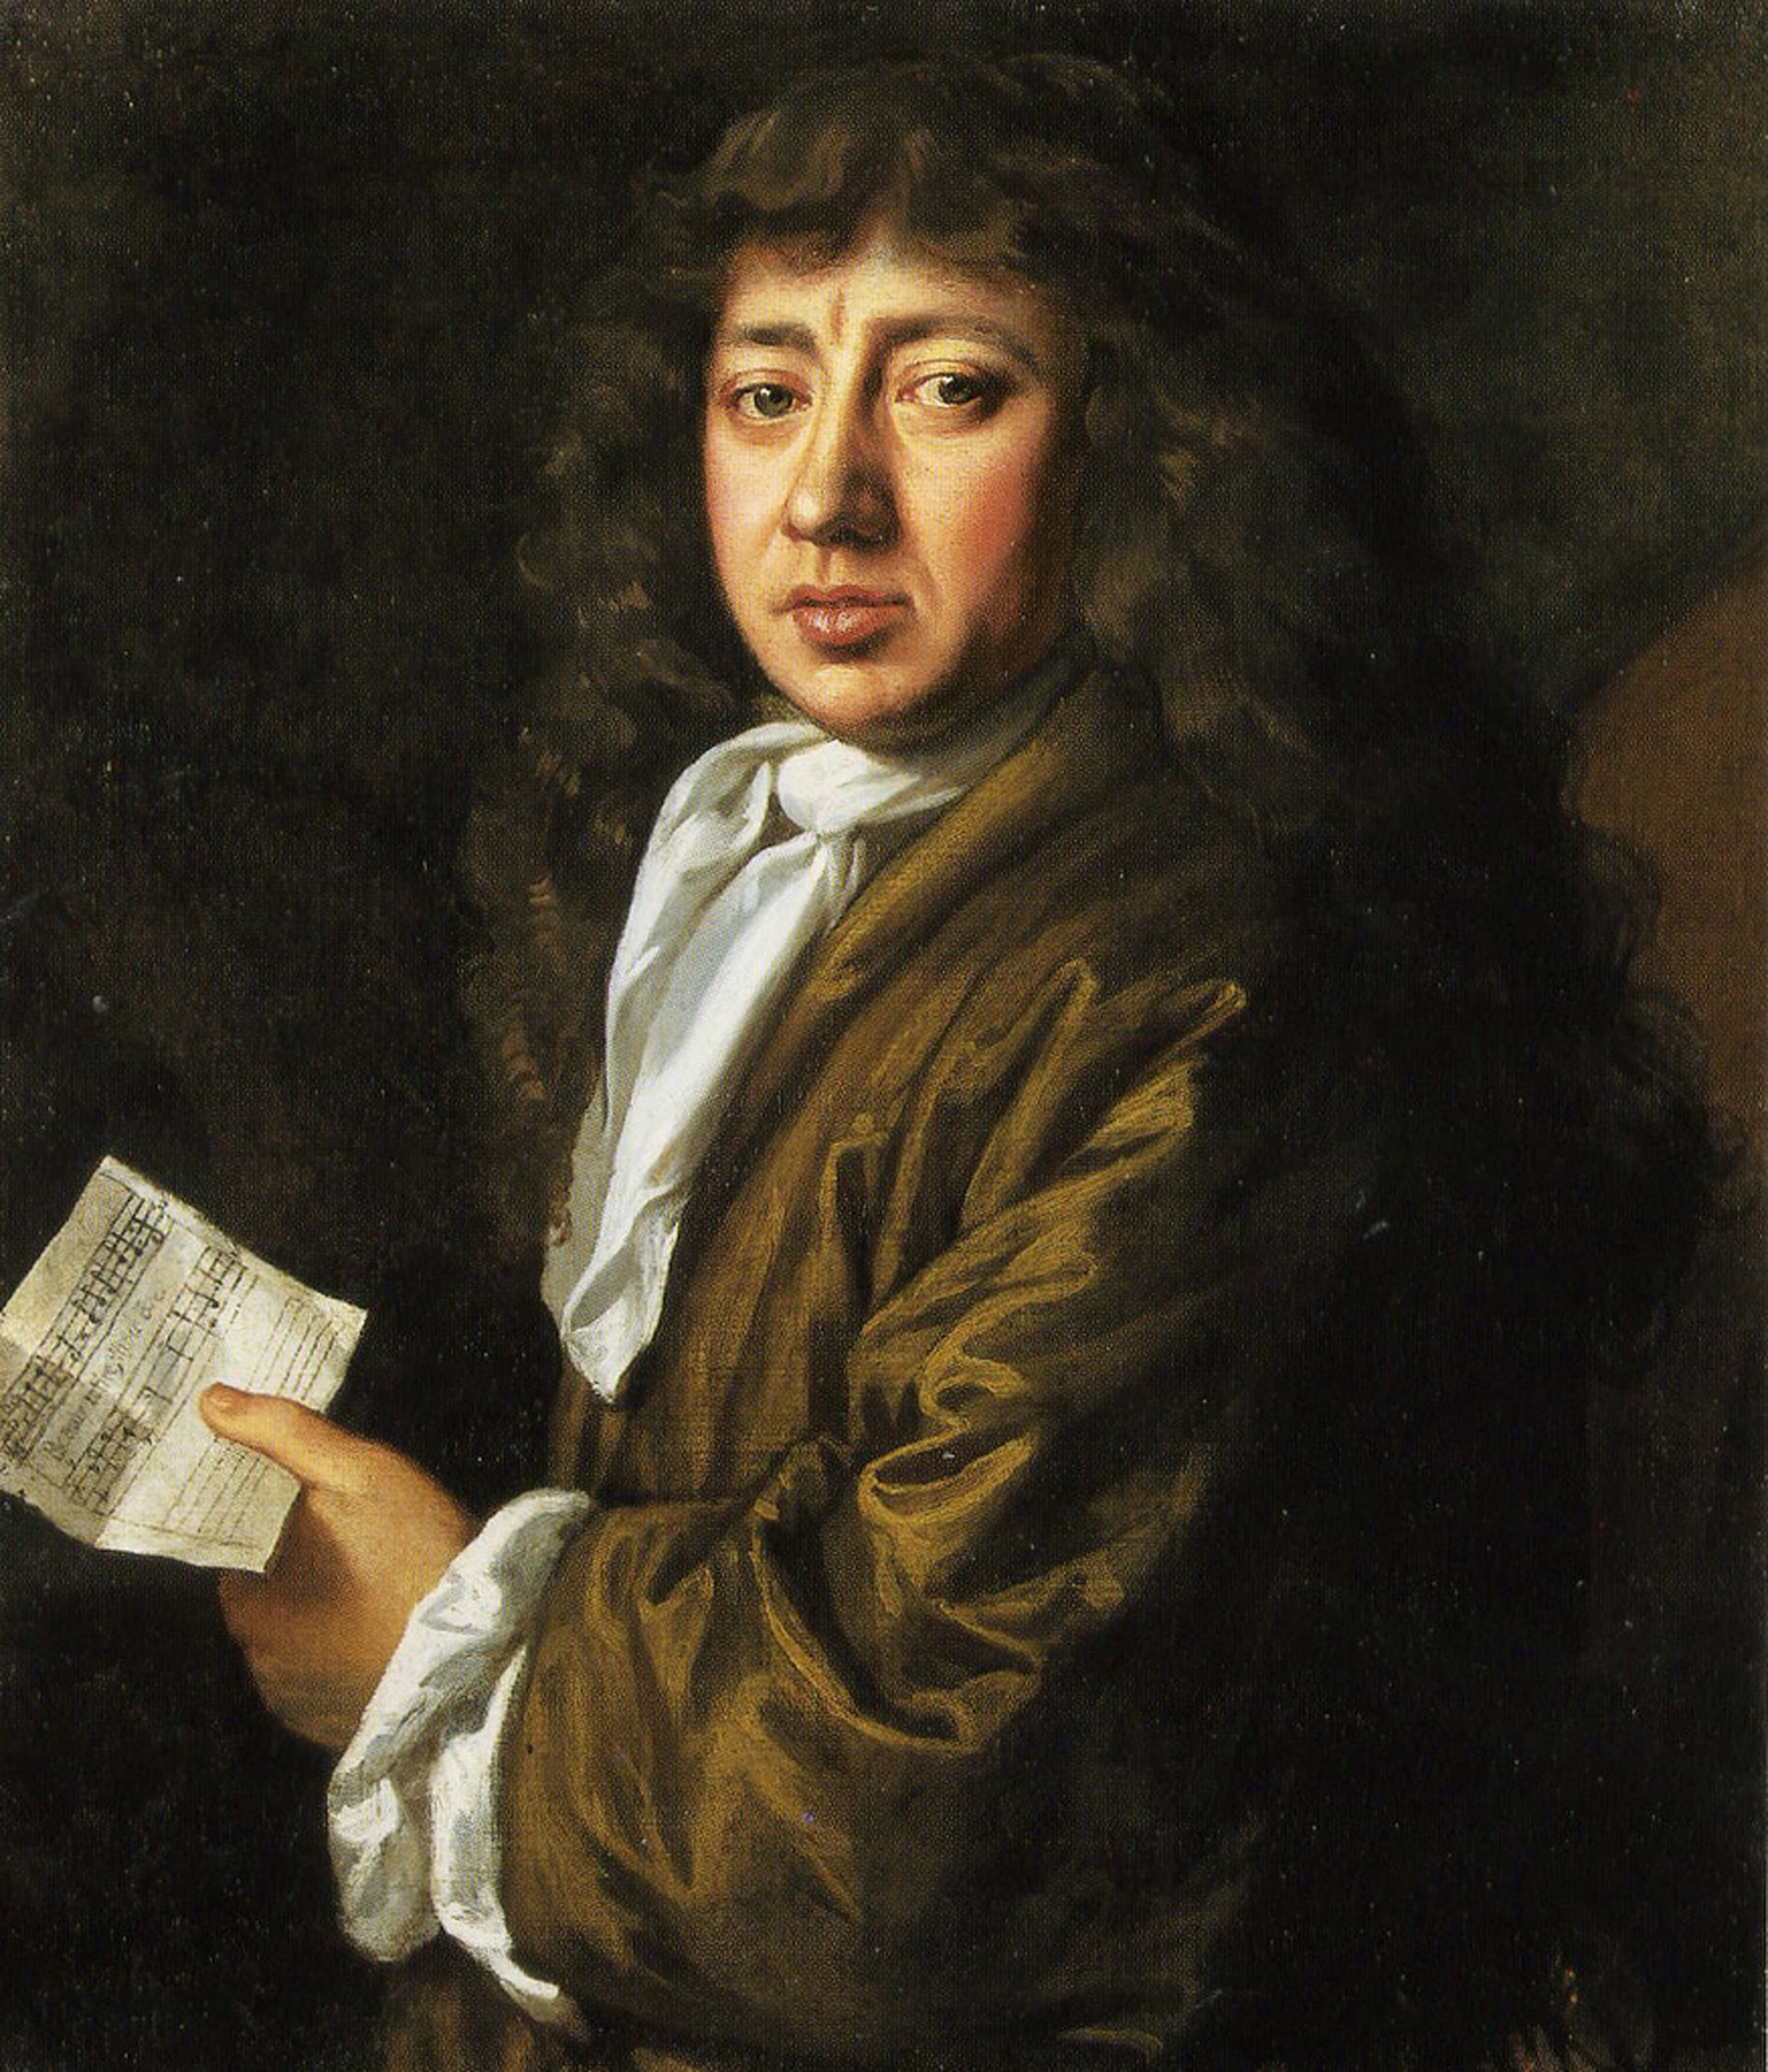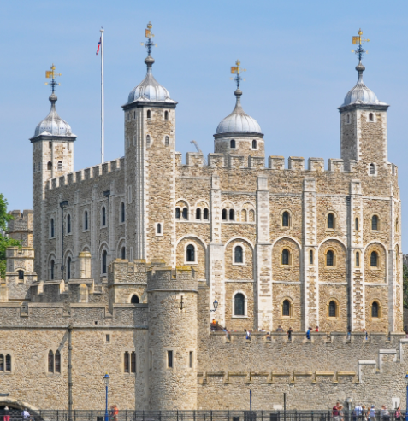
Vocabulary (Words I need to know)
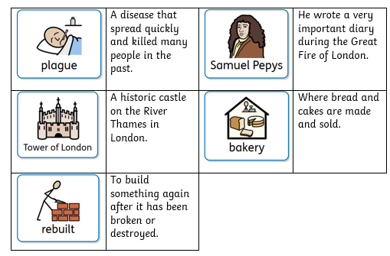
A diagram to help me understand.
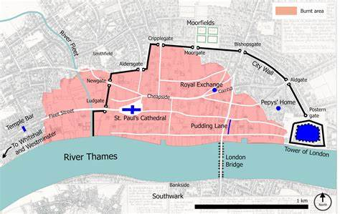
Inquisitive Thinkers • Inspired Learners • Kind hearts
Agape
Courage
Thankfulness
Great Fire of London: Was the Great Fire of London really great? Tell someone what do you think and why.

Topic
Year 2 Knowledge Organiser

