chools Music Education Self-Assessment
This is a self-assessment form and therefore a substantial document to cover all aspects of music provision. Please work through the pages and questions carefully and as honestly as possible as this will enable better support to be given. You can complete it over time if you need to check information and a reminder link will be sent. We are aiming to have all self-assessments completed as soon as possible, ideally by the end of February. If you have any difficulties please email cm@cambridgeshire.gov.uk and we will provide support.
You can use this form as an individual school or a Trust Lead for Music to record information which will:
- self-assess your music provision in school
- benchmark your own provision against National Plan for Music Education Objectives for schools
- Provide a copy at the end for use in school music development planning to meet National Plan requirements (if you are unable to do this, please ask the Hub to send a copy to you by emailing cm@cambridgeshire.gov.uk)
- Automatically share this with the Music Education Hub for Cambridgeshire so that you can engage in development support conversations. The hub will create a set of development areas from your information for your own use in shaping your development plan, within a template format that you can easily edit.
- Check progress by re-assessing over time
If completing as a Trust Lead - it is suggested that you adopt one of the following methods of assessing depending on the question:
- what you expect based on Trust information provided already to your schools about music development
- your knowledge of all your schools taken as an average
- your knowledge of the minimum level of development across your schools
How the data is used:
- the data is stored and managed under Cambridgeshire Music's Privacy notice available online at www.cambridgeshiremusic.org.uk
- your individual data is only available to you and the Music Education Hub and will not be shared with anyone else
- The Hub will use the information provided as part of support conversations for school music development or to produce anonymised summaries of overall assessment of provision.
Required
1.About you - please enter information so that you have a record of who completed the self-assessment and background information and the Hub is aware of the main contact for any requested follow up discussion. For example, Name, Email address and your role within your school.
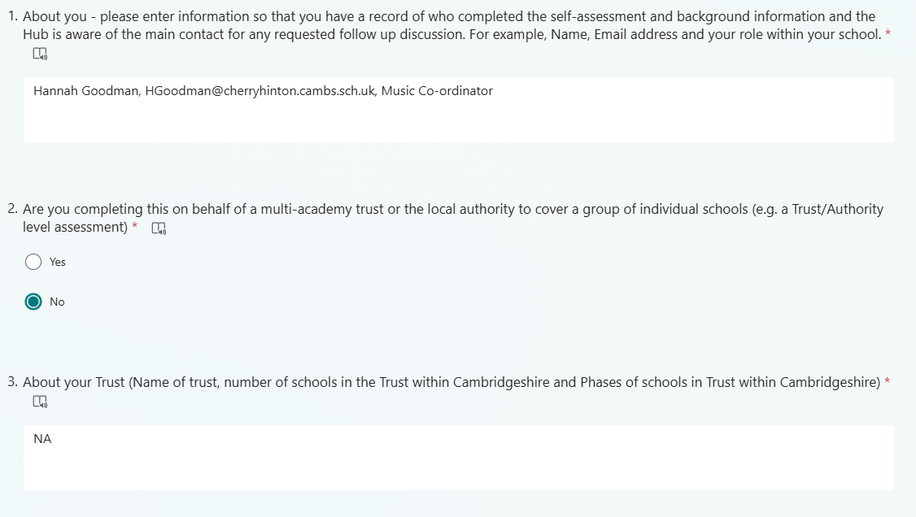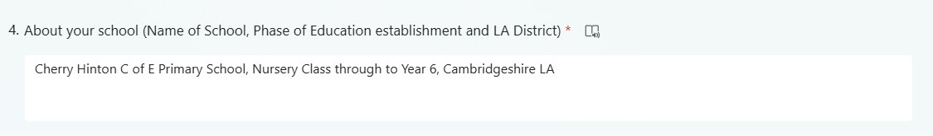

Self Assessment of Music Education Provision
This section is about how you plan and monitor your music education provision in school or across a Trust or the LA and will help create a baseline for what you already do. It is not about the planning for curriculum delivery - that is covered later.

5.Do you have an up to date and complete development plan specifically for Music in School (or Trust/LA level)? This is a detailed focused document on music, separate but probably informing an overall school development plan.
Yes YES
No
6.Is your Music Development Plan incorporated formally into your school development plan?
Yes
No NO
7.Which of these elements are included in your planning document? (Please answer for each row - based on reference to your music development planning document as of now if you have one)

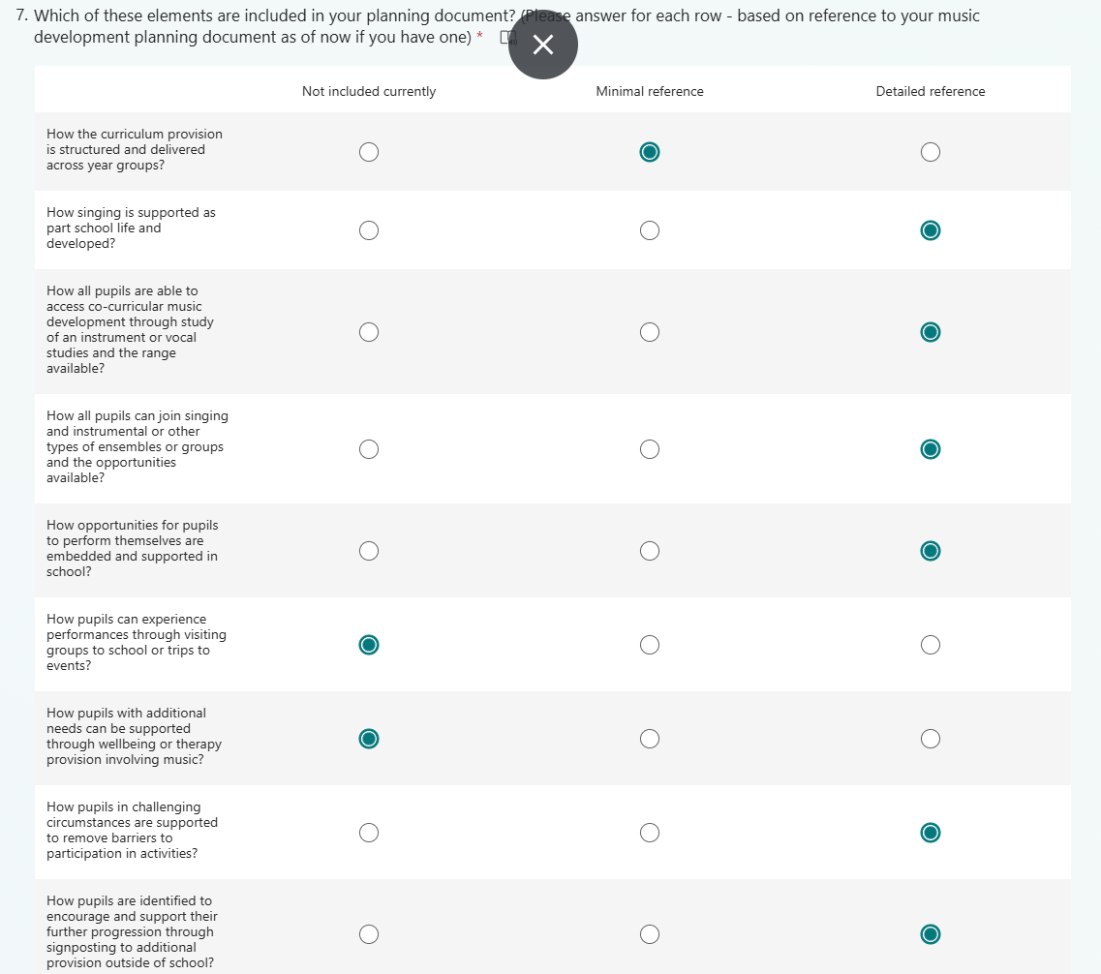
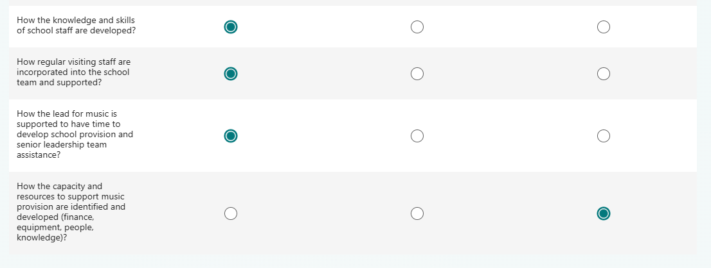

.How do you integrate your school or Trust plan with the Local Music Education Hub plan and priorities at present? It is likely, as this is a new part of the national plan that this is not particularly established. In which case, you may wish to use the comment box at the end to provide feedback on how the following strategic areas relate to your current plans and development.
The hub's current strategic focus is in four parts: growth in the amount and range of opportunities for children and young people, embedding creative thinking and creativity more deeply in provision, using technology effectively to extend access and support creative music technology study and ensuring inclusive planning and targeted work to engage children in challenging circumstances or broaden music styles and genres available.
Two programmes of development are focused on these - the settings development support which includes this self-assessment mechanism and help to develop school music plans and provision and the development of individual journey planning with pupils to support their progression.

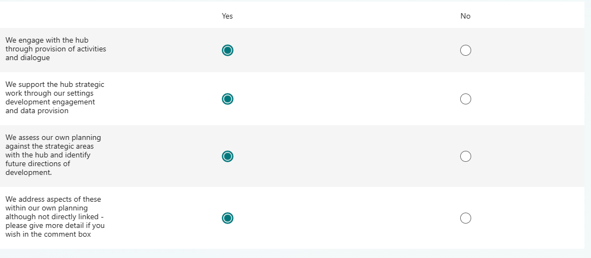

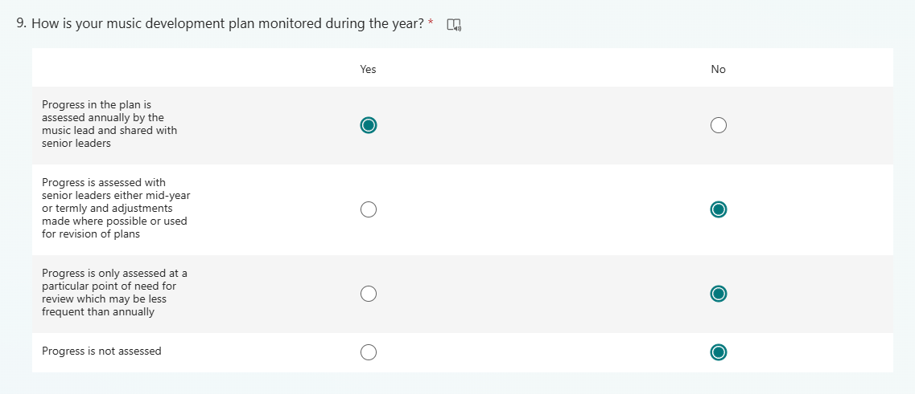
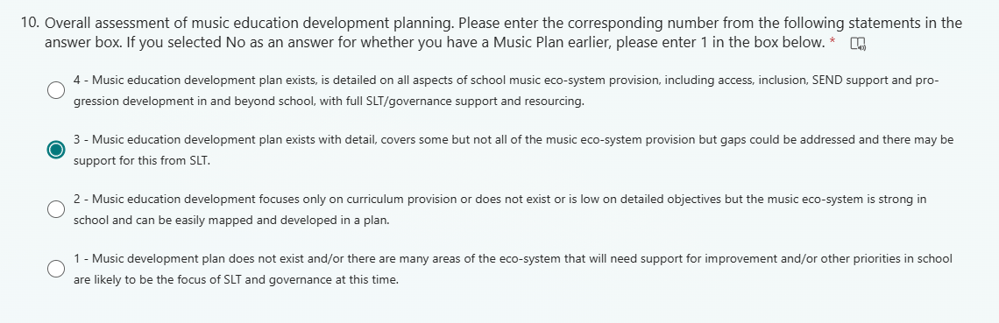
elf Assessment of Curriculum Music Provision
This section focuses on the way curriculum music is planned and delivered across year groups within national policy expectations.
11.Please assess your curriculum mapping and implementation across the following questions - one answer per row. For Trust leads you may want to consider the guidance provided to your schools or support where these areas apply to one or more to assess the best fit of the statements.
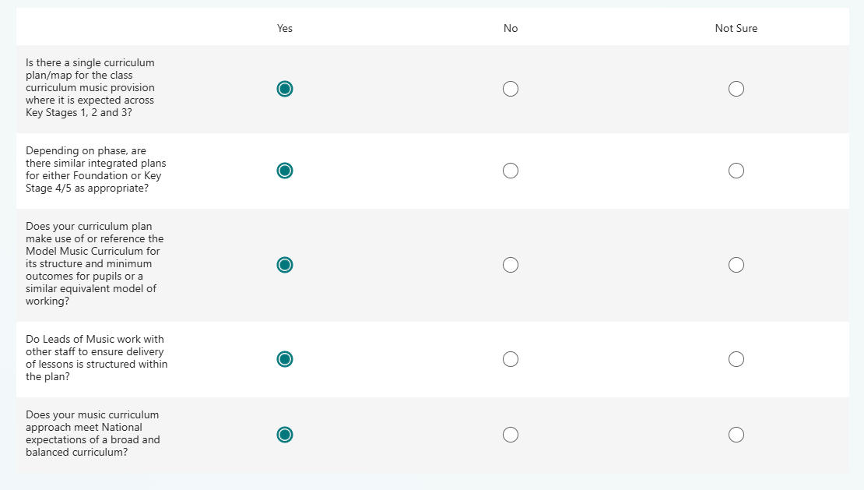
12.On the basis of your current curriculum planning please rate how sequential and progressive you believe your approach to be. National focus is that learning is built on previous knowledge as pupils continue to learn. Within music this will mean the extension of knowledge over time in core musical elements whilst new or more complex knowledge and skills is introduced to broaden understanding. Where topic approaches are used in school, this may require some help to ensure the sequential development is built in.
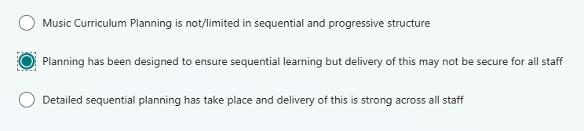
13.Based on your current knowledge of outcomes in music at the end of primary school phase or the start of secondary school (e.g. Year 6/7), for each row below, please give an indication by pupils of achievement of national plan outcomes.
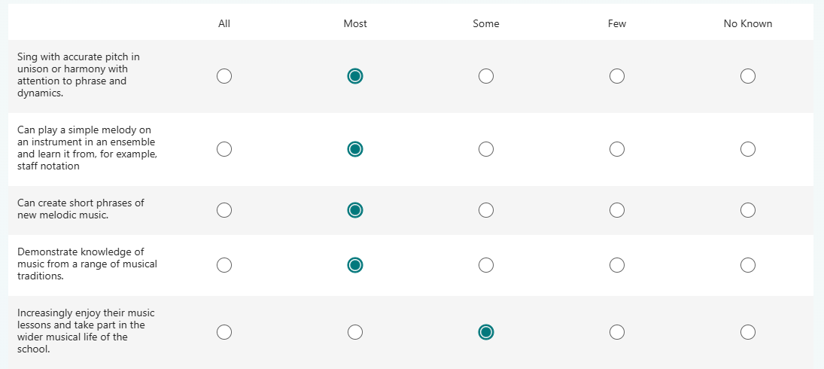

14.How is music curriculum provision timetabled for pupils in Key Stages 1-3? Please skip question if not applicable.
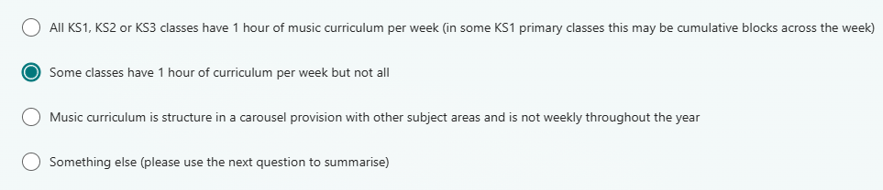
15.Summarise if you have clicked 'Something Else' on the previous question - How is music curriculum provision timetabled for pupils in Key Stages 1-3? Please skip question if not applicable.
NA

16.Other curriculum offer questions to consider - please enter for each row.
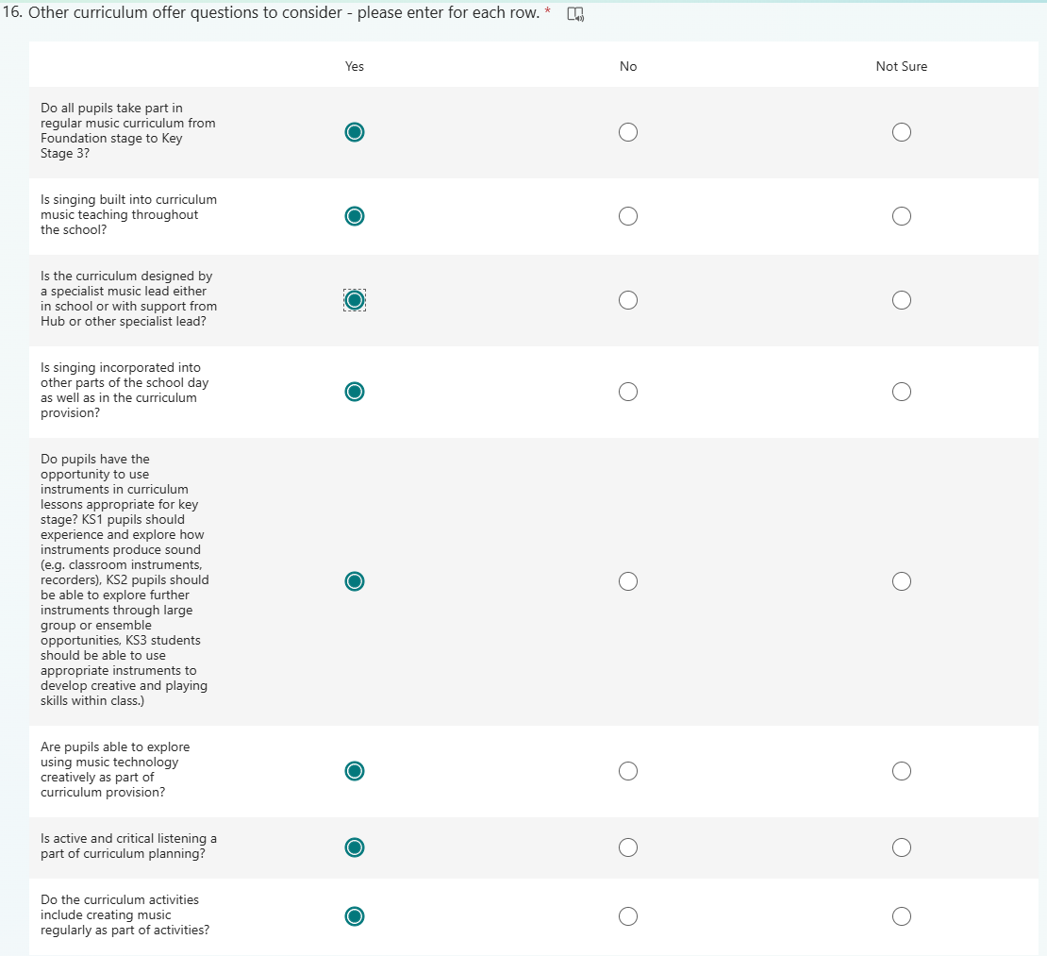
17.How are pupils encouraged to develop their instrumental skills and knowledge within class based curriculum activities?
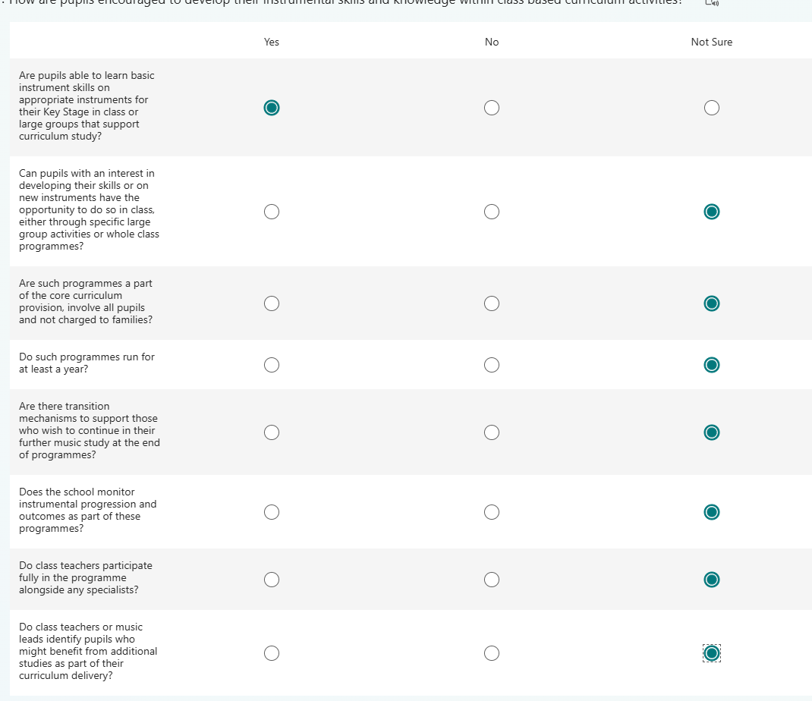
18.Please self-assess your curriculum music provision overall based on the responses you have given to the questions by entering a score based on the following statements.
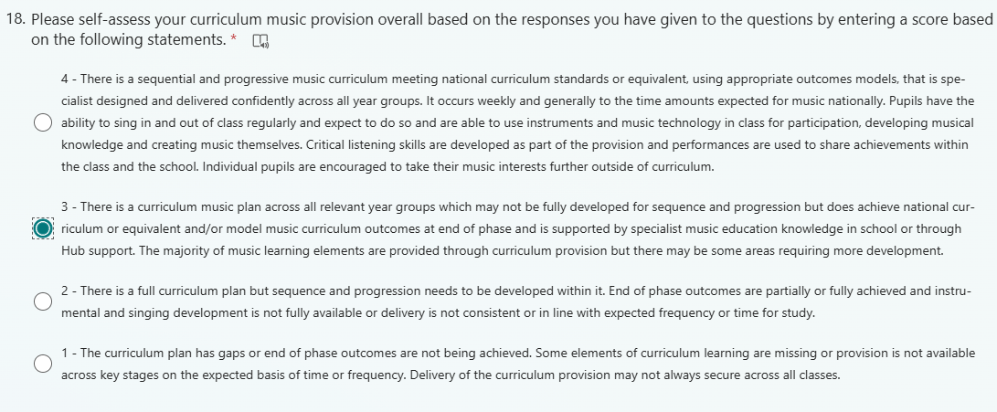
Co-curricular Provision
This section of your self-assessment looks at the music eco-system in school beyond the curriculum provision.

19.About further opportunities for vocal and instrumental studies. Please enter an answer foreach of the rows.

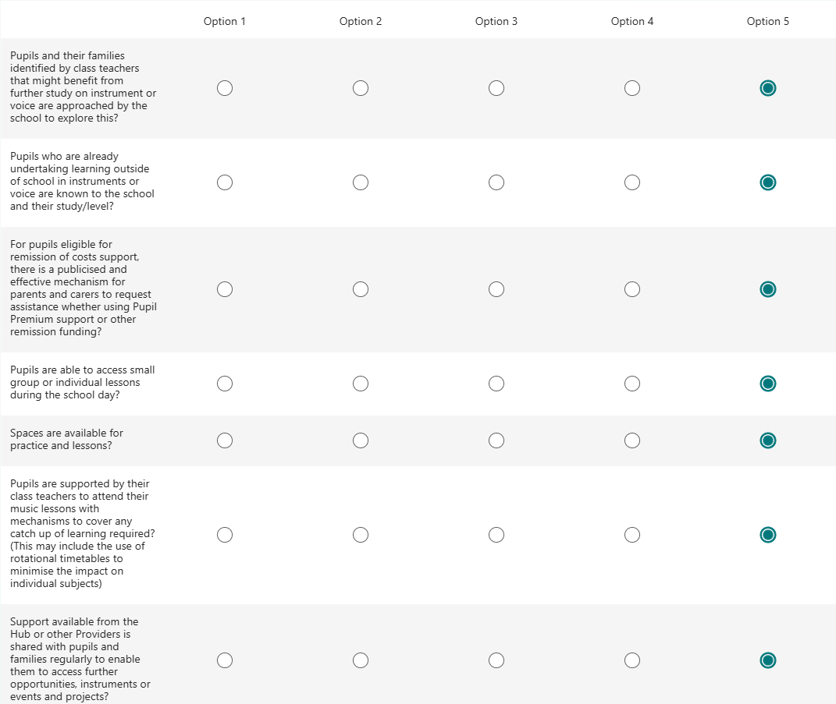
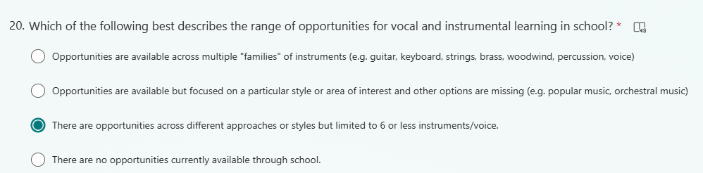
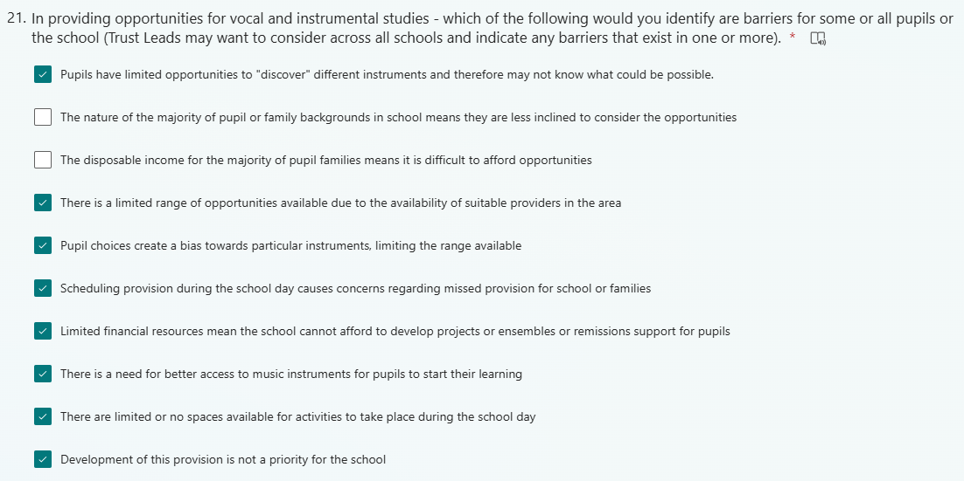
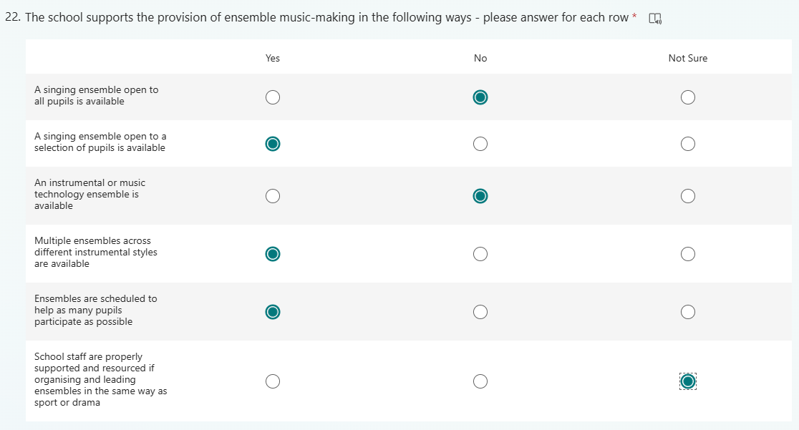
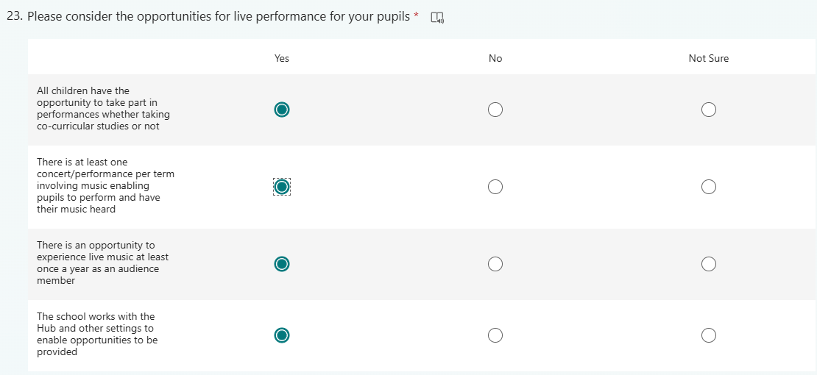
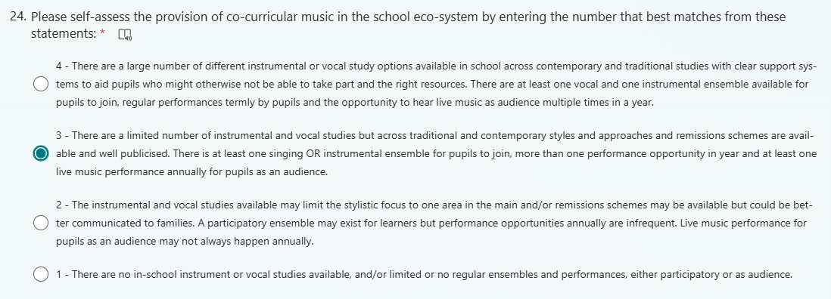
Understanding & supporting pupil progression, staff knowledge & those with additional needs
This page looks at how the school recognises and understands what pupil progression looks like for instrumentalists and singers as well as in the classroom including school staff development, how pupils with additional needs are supported and how it connects pupils with the wider opportunities available for them.
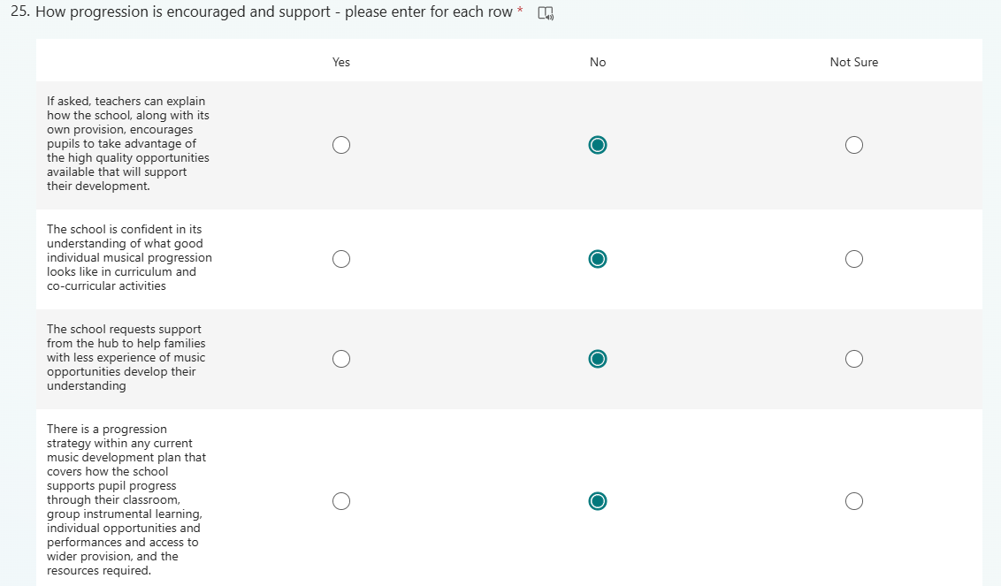
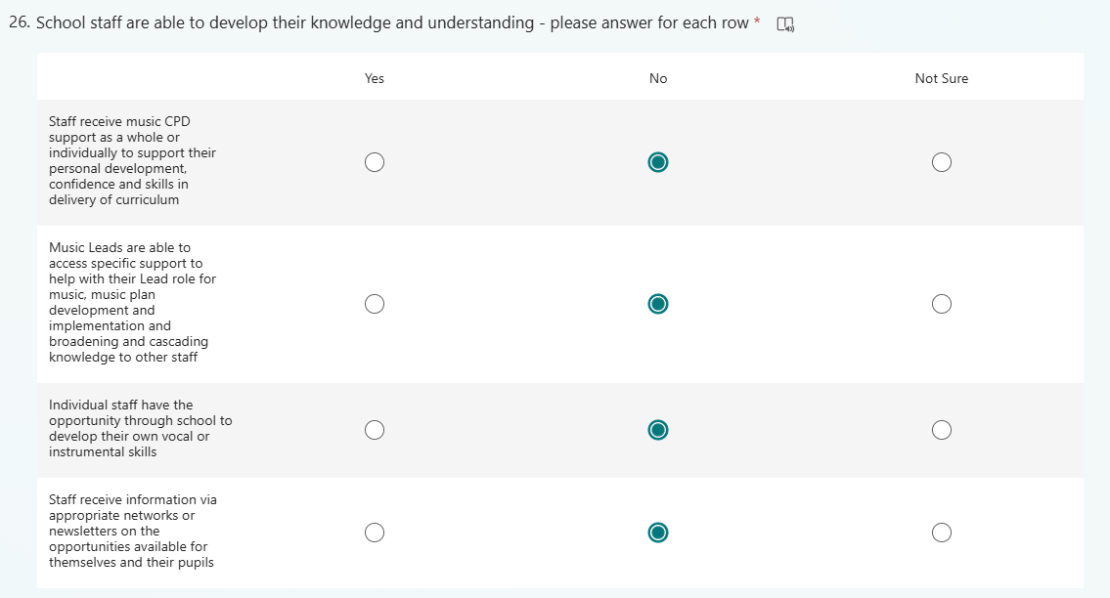
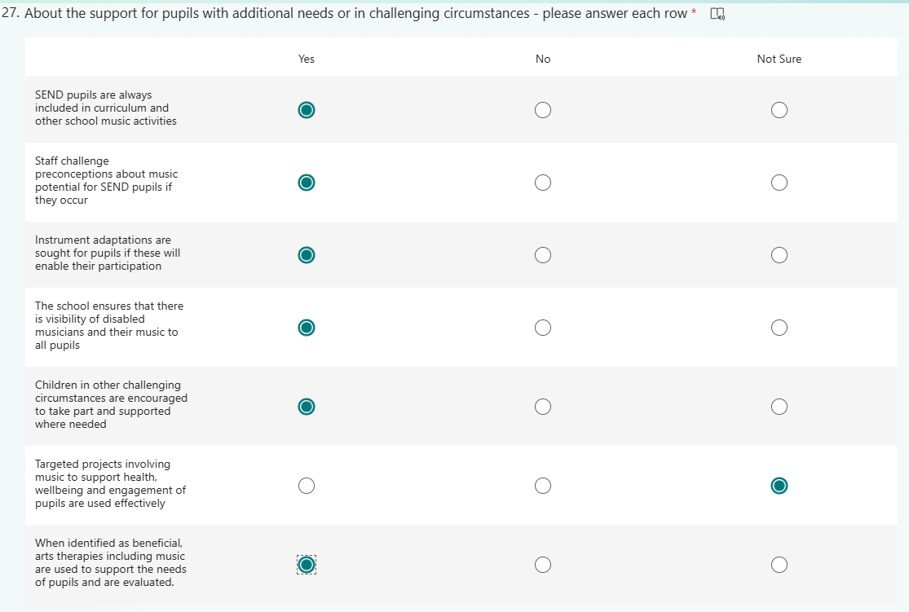
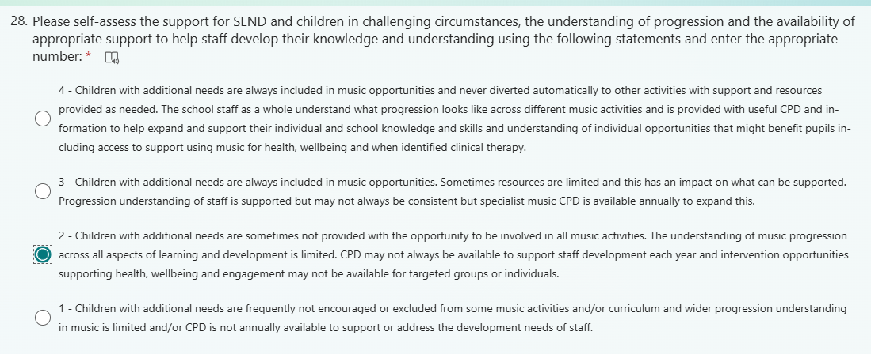
Thank you - last question
You've done your self-assessment. Please tick the option to have a copy sent to you at the end - if this does not occur, contact cm@cambridgeshire.gov.uk and we will forward to you.
We will compile cross-county anonymous information from the results and share this with you over the next few months and any changes to local plan priorities that result from this.
We will send a model music development plan template later in the Spring Term that schools can use their self-assessment answers to edit and quickly create a draft set of development areas. Further information will be provided with the template.
If you would like support from the Hub in creating an achievable and realistic plan please indicate this below and we will be in touch.
29.At this time (you can come back to us later) would you like further specialist support from the Music Education Hub to help translate self-assessment into a forward development plan? (We anticipate doing this work with schools during the summer term so if uncertain you can wait until the model plan that can be edited is circulated and advise us afterwards).



