
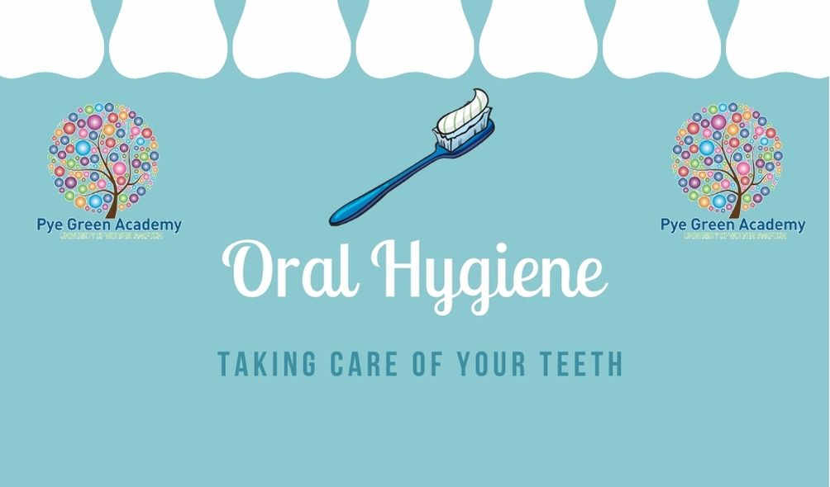
As part of the EYFS framework, children in the Early Years need to learn to know and talk about the different factors that support their overall health and wellbeing:
Regular physical activity Tooth brushing Sensible amounts of ‘screen time’ Healthy eating Good sleep routine. Drinking water



