Planning for Learning
The cycle of observation, assessment and planning is carried out on a moment by moment basis.
We have Focus Children each week (approximately 10% of the children in nursery).
Activities that occur are recorded when the cycle is complete. These records are added to the children’s online learning journal – Tapestry.
The focus children are asked to send in photos from home to let us know all the recent events in their lives at home. This information is used to support assessment and next steps. The child’s Key Worker meets with their parents/carers at the end of the Focus Week to discuss their development and how parents can support their Next Steps at home.
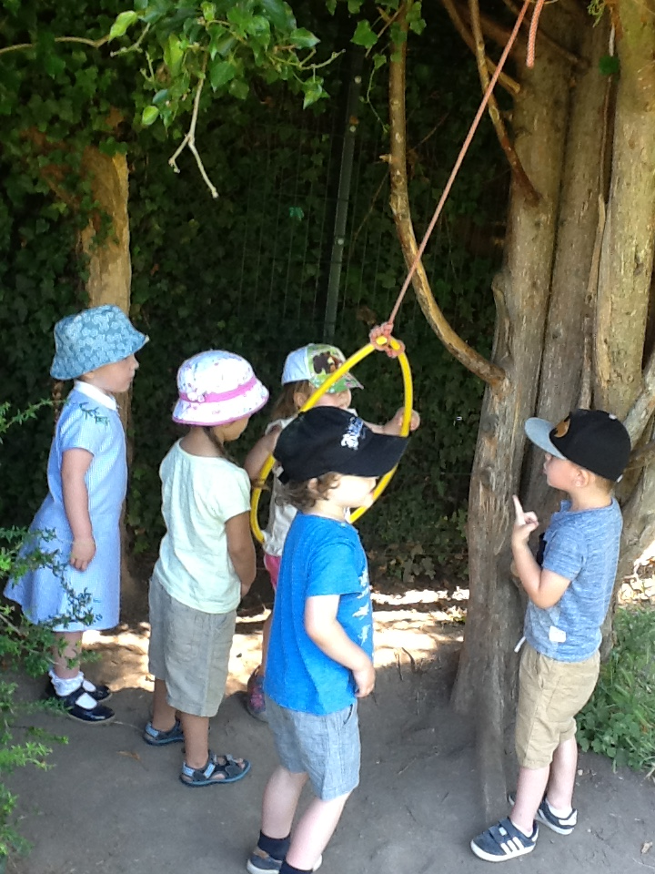
We work in this way because…
“Babies and young children are experiencing and learning in the here and now, not storing up their questions until tomorrow or next week. It is in these moments of curiosity, puzzlement, effort or interest – the ‘teachable moments’ - that the skilful adult makes a difference.
By using this cycle on a moment by moment basis, the adult will always be alert to individual children (observation), always thinking about what it tells us about the child’s thinking (assessment) and always ready to respond by using appropriate strategies at the right moment to support children’s well-being and learning (planning for the next moment).”
From National Strategies document Learning, Playing and Interacting p22-23

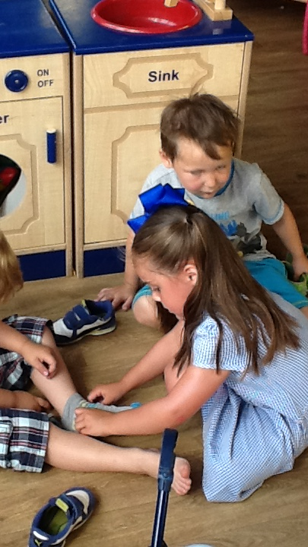

“Teaching is all those difference things that you do as adults to help young children learn….communicating, modelling language, working with children as they initiate their own play and activities, being ready to intervene in the moment, demonstrating how to do something, explaining why something is as it is, showing children something, exploring ideas with them, encouraging them, checking what it is they are understanding, helping them to record something that they did so that they get the structure and sequence of events, providing a narrative for what they are doing, facilitating what they are doing, setting challenges, all those sorts of things are the sort of things we mean when we talk about teaching.”
Jane Wotherspoon – Lead HMI for Early Years

“Practitioners must consider the individual needs, interests and stage of development of each child in their care, and must use this information to plan a challenging and enjoyable experience for each child in all areas of learning and development.”
Revised EYFS 2014

At Cherry Hinton Nursery adults will…
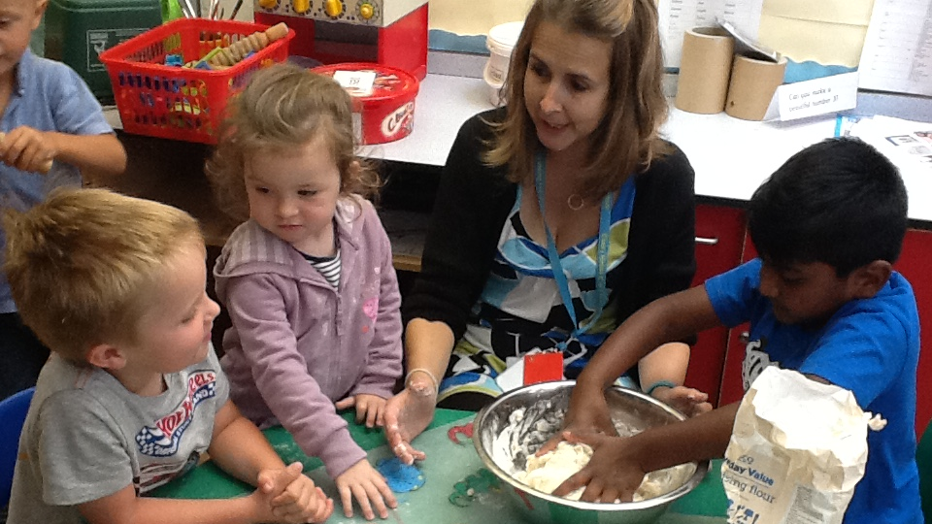
Spot ‘teachable moments’. Engage in quality interactions. Record the progress each child makes. Go to the children and take the learning to them.
Enhance learning not interrupt it. Ask “I wonder…” questions. Try not to speak until the child requests it and finally…be relaxed!
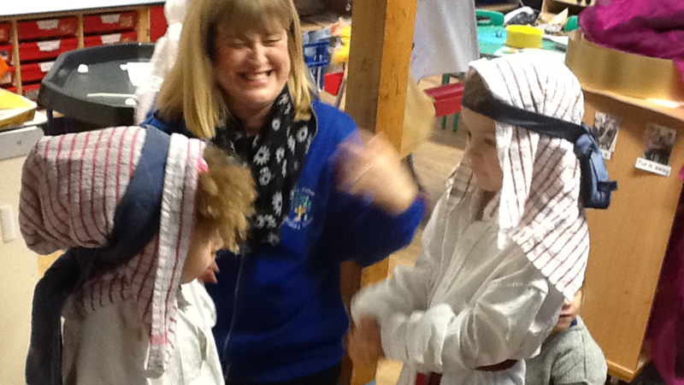

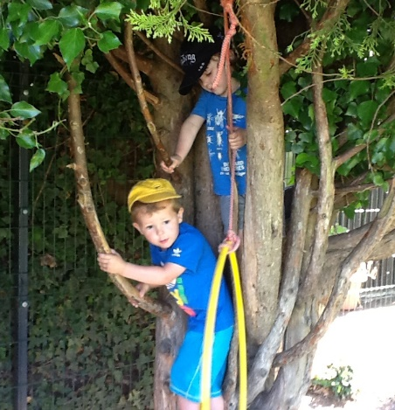
We have FOCUS CHILDREN NOT FOCUS ACTIVITIES. The adult goes to the child – the child is not called to come to the adult.
We work this way because research has shown that high-level involvement and learning occurs in child-initiated activity.

An Enabling Environment
We have a workshop style environment both indoors and outside.
Our aim is not to ‘set out’ adult-led activities for the children, but rather to provide high quality, open-ended resources and support the children to select what they want to do.
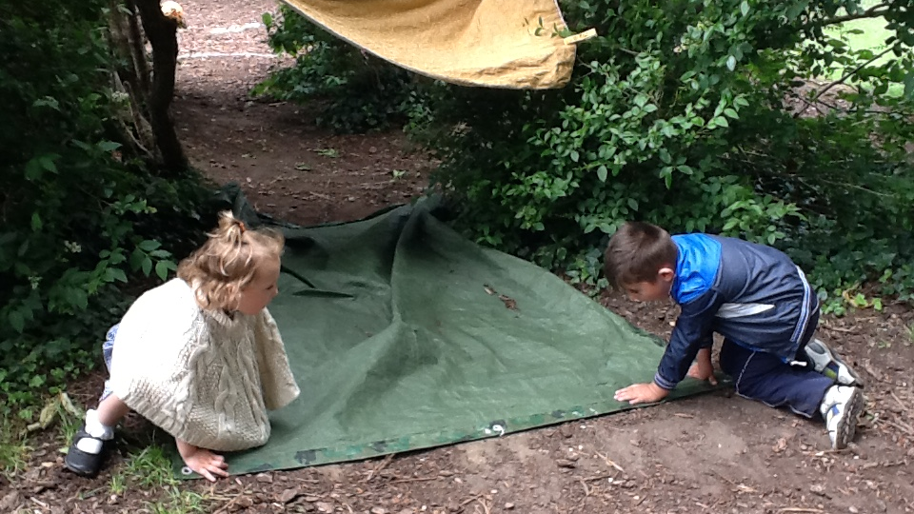

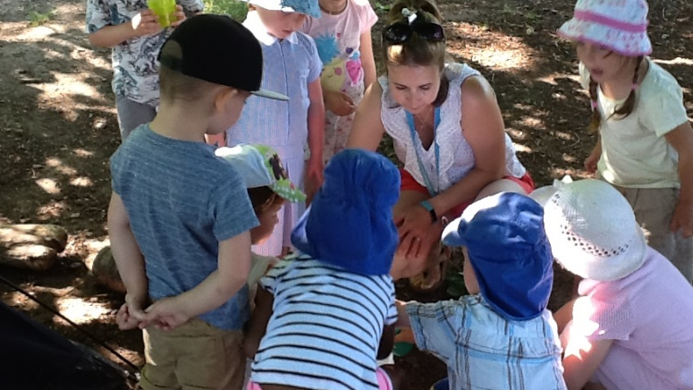
The Role of the Adult
The adults are there to facilitate learning. They do this through observations and interactions.
Our adults know the children very well and have a sound understanding of child development. This ensures that they enhance and extend the learning at the appropriate level.
Meaningful Interactions
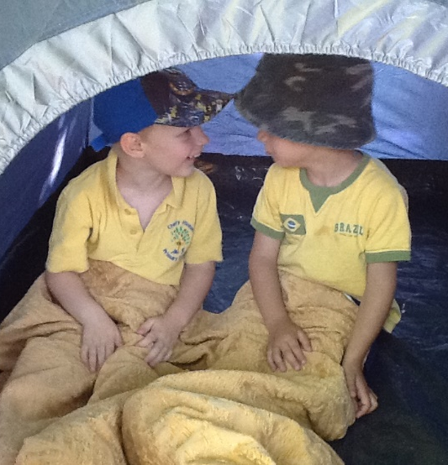
The children and adults have time and space to engage in meaningful conversations. The children set the agenda and the adults are there to show interest and engage with the children. The modelling of conversation skills is then adopted by the children who have animated conversations in pairs and groups. 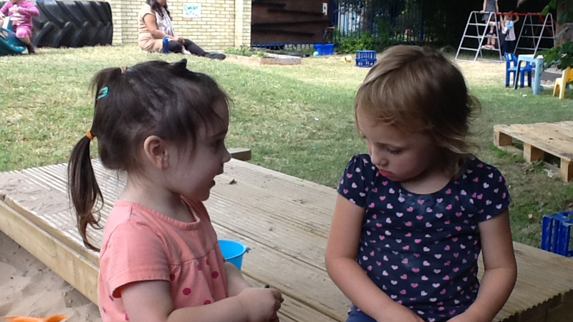

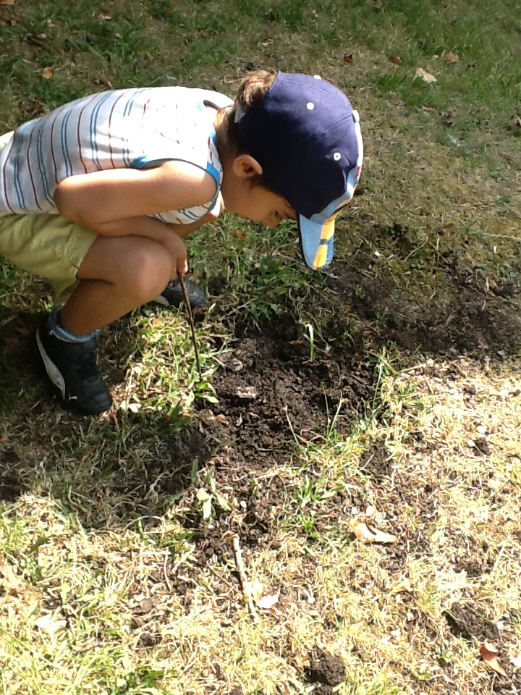

Planning in the Moment
We use the observation cycle on a moment by moment basis. The Focus Children are given extra attention, but all the children are busy and learning all the time.

These interactions are recorded by means of photos, written comments and short video clips through our online observation Learning Journal system, Tapestry.
The letter “T” is used in observations to indicate the Teaching input e.g. “T suggests…encourages…models….asks…helps…offers resources” etc
Parents also contribute to the children’s online Learning Journals with observations from home. The children also have a Special Book where they can put their own special pictures and photos, “WOW” slips recoding special achievement from home, Rainbow Cards (celebrating Characteristics of Effective Learning) and drawings with “stories” scribed by adults.

The Characteristics of Effective Learning (CoEL)
Playing and Exploring: do they investigate and experience things and “have a go”?
Learning Actively: do they concentrate and keep on trying if they encounter difficulties, and enjoy achievement?
Creating and Thinking Critically: do they have and develop their own ideas, make links between ideas and develop strategies for doing things?

We comment on the CoEL in the childen’s online Learning Journals (Tapestry).
Within our recording and assessment, we use the Leuven Scales of Well-Being and Involvement.
Well-Being is linked to self-confidence and good levels of self-esteem and resilience. Involvement refers to being intensely engaged in activities and is believed to be a necessary condition for deep level learning and development. 

