Activity Idea

**18th April was a Heritage Day**

**Top 10 Family Days out Map**

You can create a Top 10 what you already visited or where you would like to go. It’s your choice!

You will need:

1. Picture of a place. You can use your own if you already were here; You can find picture online; or you can draw it!
2. A3 sheet of paper and a glue.
3. Lots of colours.

How to do:

If you decided on your Top 10, stick pictures on a A3 sheet and write what was good about that place or why you would like to visit it. Decorate whole sheet of paper.

Top 10 can be local park, seaside, forest, back garden…. Enjoy time together!

## 1.Dover Castle, Kent. “A brilliant mix of histories for children of all ages. Space to explore and run about, plus amazing views of the channel to boat!”. 2. Kenilworth Castle and Elizabethan Garden, Warwickshire. “Kids have plenty of open spaces to feed their imagination. There are so many fun activities throughout the year, they can never get bored!”. 3.Whitby Abbey, North Yorkshire. “It is a beautiful and magical place, steeped in history it makes children feel part of something bigger-amazing memories to be made!” 4. Audley End House and Gardens, Essex. “Lovely house, gardens, many activities for children, a lake, good parking-an ace adventure for little ones.”5.

Parent Carer Support Line 

Offers the opportunity to speak to friendly professionals from the E I Family Worker Team about your young person aged 4 to 12 in Cambridge City and surrounding areas.

Please ask questions, seek support around behaviour, routines, and boundaries, or just talk about how it is to manage parenting during current times. We will advise, support, and signpost, or, just listen. You can telephone or email for support any time. Please leave a message with contact details, someone will call you back within 10 working days. We are not an emergency service. Phone 01354 750420 Email- Districtearlyhelpteam.cambridgecity@cambridgeshire.gov.

Another Resource

<https://www.dayoutwithkids.co.uk>

[Gardening for children - Better Health Channel](https://www.betterhealth.vic.gov.au/health/healthyliving/gardening-for-children)

[Children: getting them interested in gardening / RHS Gardening](https://www.rhs.org.uk/advice/health-and-wellbeing/children-getting-them-interested-in-gardening)

Parenting Top Tip

Getting children interested in gardening

* Keep it simple.
* Give children their own garden space. (This does not have to be big. You can start with a large container or a few pots.)
* Involve older children in the planning and design of the garden.
* Use lightweight, easy-to-handle, correct-sized tools and garden equipment.
* Encourage children to dig in the dirt. (Younger children love making mud pies)
* Grow interesting plants such as sunflowers, corn, pumpkins, tomatoes and strawberries.
* Use a trellis or tepee to grow beans or sweet peas.
* Plant flowers that attract butterflies, ladybirds and other interesting insects or birds.
* Make a scarecrow.
* Install a water feature, a birdbath or a sundial.
* Set up a worm farm.
* Visit community gardens, children’s farms or botanic gardens for ideas.
* 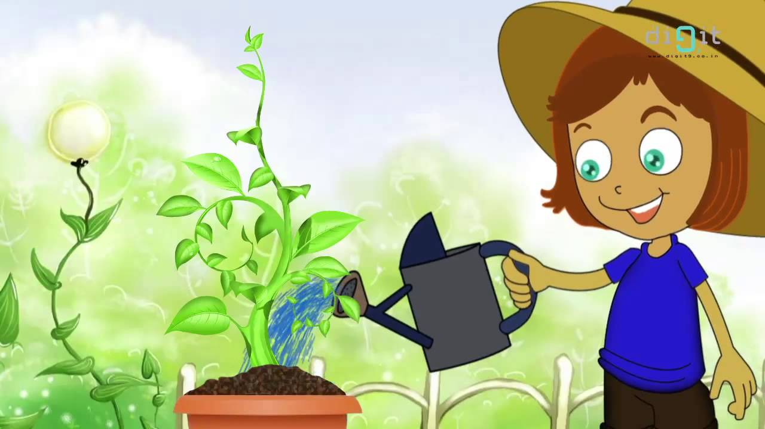

**Does** your child have, or potentially have, an additional need or disability? Pinpoint (www.pinpoint-cambs.org.uk) have lots of information, advice and tips. For Cambridgeshire’s Local Offer go to www.cambridgeshire.gov.uk/residents/children-and-families/local-offer

Early Intervention Family Worker Newsletter

19th April 2022

**Contact me directly on  07 or**

** @cambridgeshire.gov.uk**