Parenting Top Tip

**Good Sleep Routines.**

Everybody can benefit from having a good sleep routine. A good sleep routine needs to be planned and consistent.

First, you need to consider what time bedtime will be and then work backwards, planning the hour leading up to bedtime.

Here are some tips for creating the ideal bedtime routine:

* Turn all screens off an hour before bedtime.
* Dim the lights, close the curtains/blinds, and create some darkness – this promotes melatonin (sleep hormone) production
* Offer quiet activities. – skills that use fine motor skills are great at aiding relaxation, like a jigsaw, colouring, building bricks.
* Baths are great for relaxing children.
* Get ready for bed in the same order – for example, Pjs on, brush teeth, toilet.
* Reading a story with your child will also aid relaxation.
* Give hugs & kisses, and tell your child ‘its time to go to sleep’
* Try to wake your child up at the same time every morning. – this helps to strengthen their body clock.

Another Resource

[**How to get to sleep - NHS (www.nhs.uk)**](https://www.nhs.uk/live-well/sleep-and-tiredness/how-to-get-to-sleep/)

Activity Idea

– Don’t wake the Shark

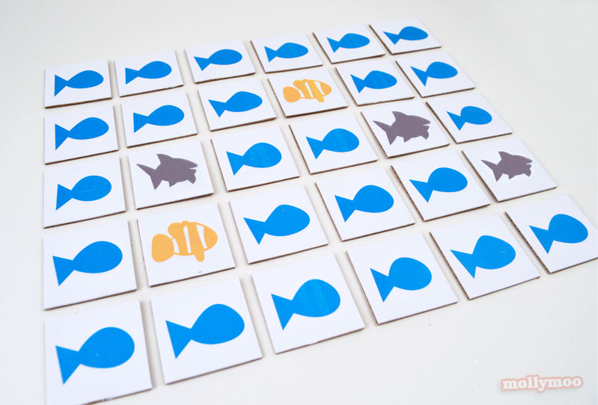

You will need to create cards that are like the ones above (you can find the printable ones at this link - [NemoPage1-mollymoo](http://cdn.mollymoo.ie/uploads/2014/01/MollyMoo-matching-pairs.pdf))

Shuffle the cards and then lay the cards out, face down.

Each player then takes turns picking up two tiles, and keeps the matching pairs to one side.

If a player turns over a shark, they miss a turn.

The first player to find the only matching clown fish pair wins.

City News

Virtual Free Workshops

23rd February at 10am – Sleep

([Shelley.bari@cambridgeshire.gov.uk](mailto:Shelley.bari@cambridgeshire.gov.uk))

3rd March at 10am – Parenting styles and labelling

(Amanda.Gilbert@cambridgeshire.gov.uk)

**Does** your child have, or potentially have, an additional need or disability? Pinpoint (www.pinpoint-cambs.org.uk) have lots of information, advice and tips. For Cambridgeshire’s Local Offer go to www.cambridgeshire.gov.uk/residents/children-and-families/local-offer

Early Intervention Family Worker Newsletter

21st February 2022.

**Contact me directly on  07(change) or**

** (change)@cambridgeshire.gov.uk**