**For Parents and Carers of Primary aged children**

**Free Online City Workshops**

10th Feb 10.30am – Online Anxiety Workshop

23rd Feb 10.00am – Online Sleep Workshop

Please email: [Amanda.gilbert@cambridgeshire.gov.uk](mailto:Amanda.gilbert@cambridgeshire.gov.uk)

23rd Feb 10.00am -

(Lasting approx. 1 hour)

3rd February 2022

Why Time to Talk Day is important.

. One in 4 of us will experience a mental health problem in any given year.

. We want everyone to feel comfortable talking about mental health – whenever they like.

. Talking about mental health helps to create supportive communities where we can talk openly about mental health and feel empowered to seek help when we need it.

. Opening up the conversation about mental health problems is important – by talking about it. we can support ourselves and others.

<https://timetotalkday.co.uk/>

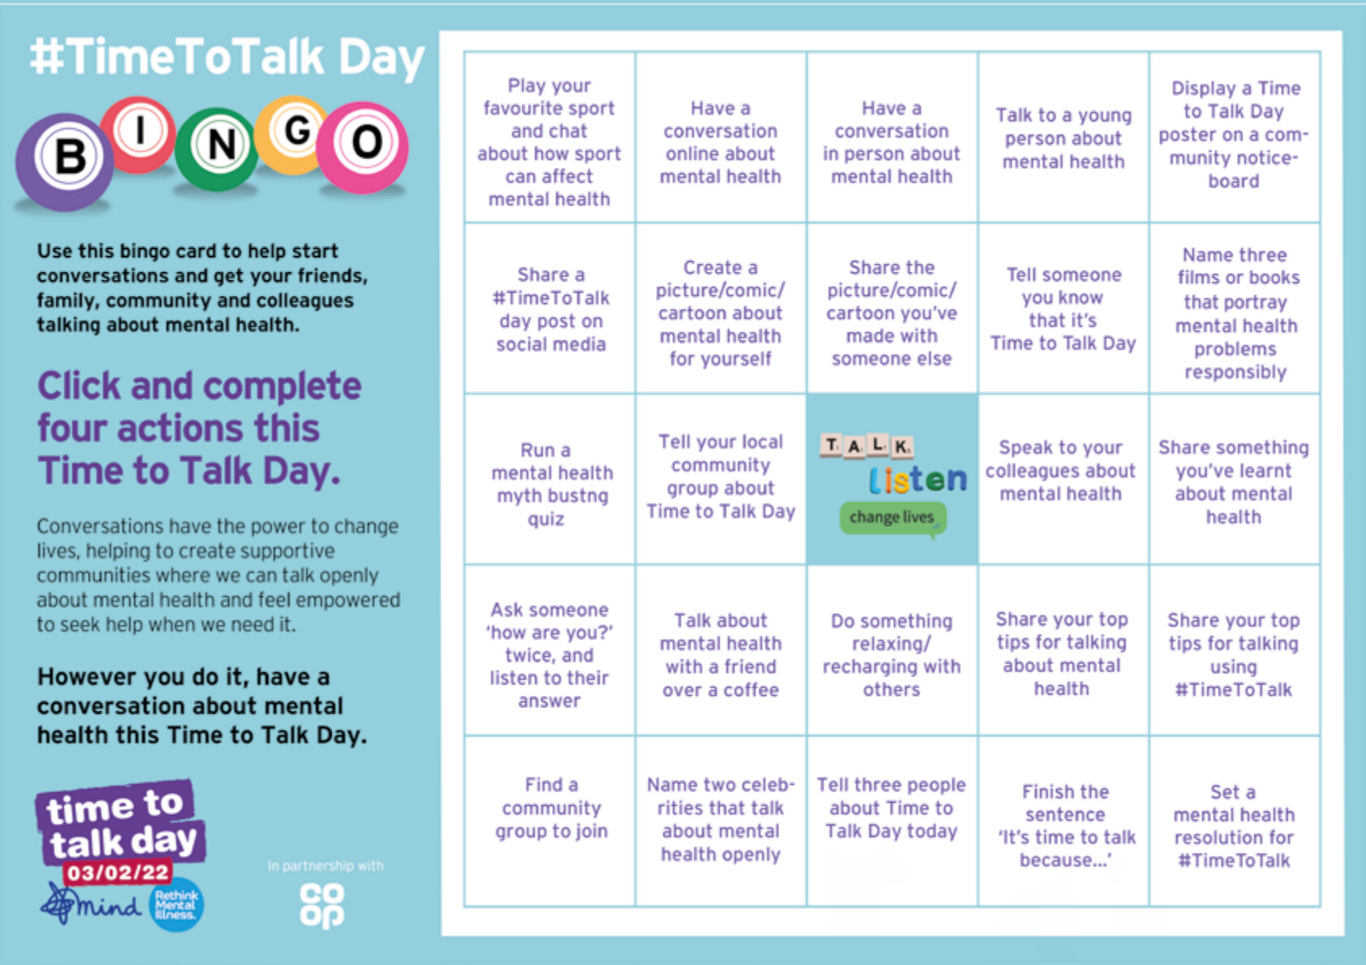

Another Resource

Every Mind Matters Signposting for children’s mental health.

[Children's mental health - Every Mind Matters - NHS (www.nhs.uk)](https://www.nhs.uk/every-mind-matters/supporting-others/childrens-mental-health/)

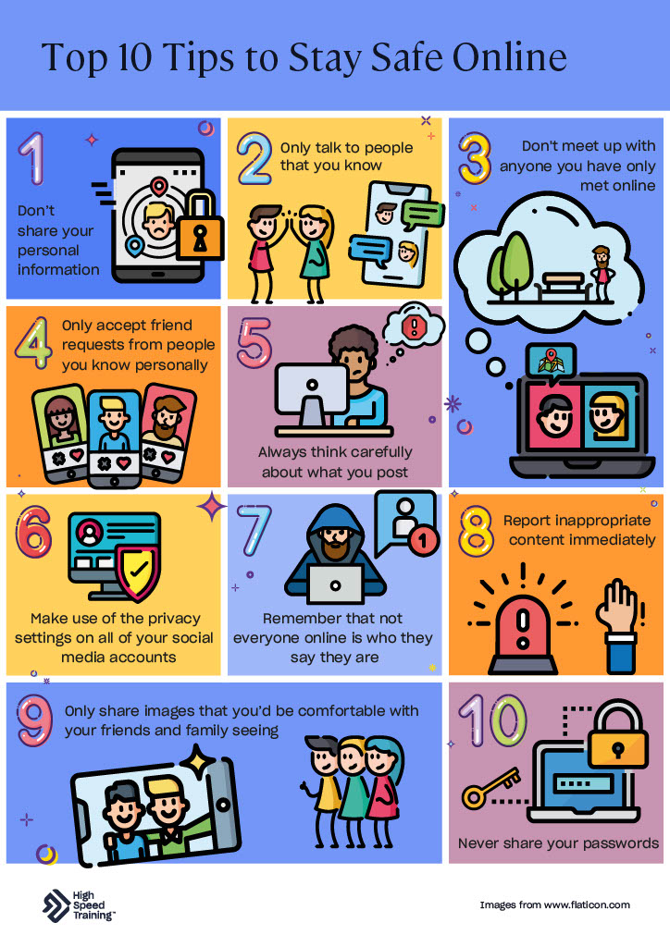

**Does** your child have, or potentially have, an additional need or disability? Pinpoint (www.pinpoint-cambs.org.uk) have lots of information, advice and tips. For Cambridgeshire’s Local Offer go to www.cambridgeshire.gov.uk/residents/children-and-families/local-offer

Early Intervention Family Worker Newsletter

7th February 2022