Another Resource

Download a lovely free calm pack full of activities, relaxation exercises and calm cards from Relaxkids:

<https://relaxkids.com/wp-content/uploads/calm-pack-free.pdf>

**Does** your child have, or potentially have, an additional need or disability? Pinpoint (www.pinpoint-cambs.org.uk) have lots of information, advice and tips. For Cambridgeshire’s Local Offer go to www.cambridgeshire.gov.uk/residents/children-and-families/local-offer

Spring is just around the corner so it’s time to put on your wellies and start exploring the great outdoors.

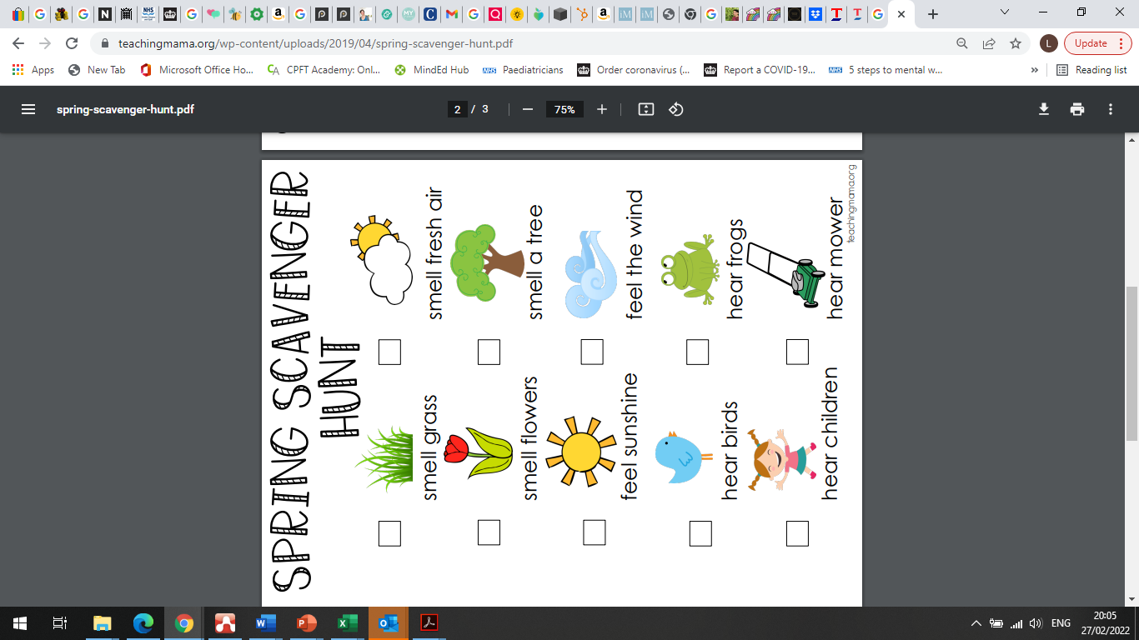

See if you can collect some nature objects while out for collages and crafts at home 😊

<https://teachingmama.org/spring-scavenger-hunt/>

City News

Virtual Free Workshops

There are still places on our Parenting Styles and Labelling Workshop. To book please contact:

3rd March at 10am – Parenting styles and labelling

(Amanda.Gilbert@cambridgeshire.gov.uk)

Parenting Top Tip

We all need a bit of self-care – what are you doing to look after you today?

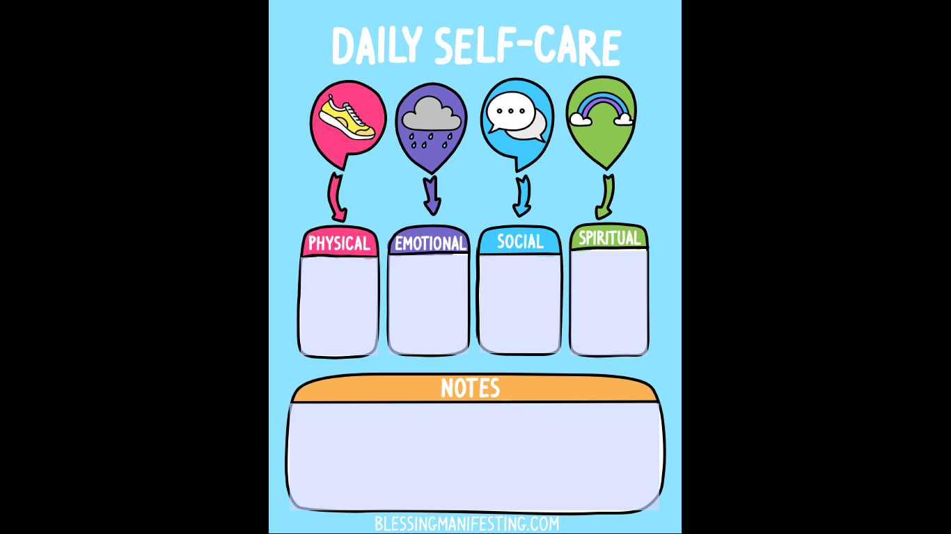

<https://www.selfloverainbow.com/2018/05/daily-self-care-worksheet.html>

Early Intervention Family Worker Newsletter

28th February 2022