Please see below our list of workshops that we are delivering this term, starting weekly from Tuesday 11th October, from 12-1pm.

* ***Supporting with feelings of worry*** *– 11th October*
* ***Supporting with feelings of anger*** *– 18th October*
* ***Support for managing conflict for separated or separating parents/carers*** *– 8th November*
* ***Digital safety*** *– 15th November*
* ***Parental well-being*** *– 22nd November*
* ***Supporting with feelings of worry*** *– 29th November*
* ***Supporting with feelings of anger*** *– 6th December*
* ***Sleep*** *– 13th December*

Link - <https://forms.office.com/r/qXaZKsEnaC>

World Health Mental Health Day

**10th October 2022**

The theme for this year’s World Mental Health Day, set by the [**World Federation for Mental Health**](https://wfmh.global/2021-world-mental-health-global-awareness-campaign-world-mental-health-day-theme/), is '**Make mental health and wellbeing for all a global priority**'.

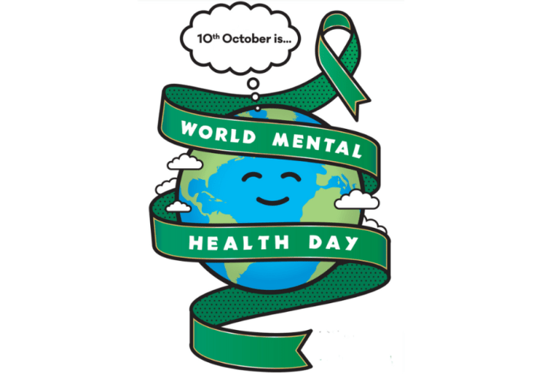

Being in touch with Nature can support your mental health. This might be as simple as tending to a house plant, listening to the birds, touching the bark of trees, smelling flowers or writing a poem about our favourite nature spot.

Even small contact with nature could reduce feelings of social isolation, effectively protect our mental health, and prevent distress.

Why not take some time out as a family this weekend for some outdoor fun and help everyone’s emotional well-being?

More info: <https://www.mentalhealth.org.uk/our-work/public-engagement/world-mental-health-day>

Activity Idea: Leaf animal pictures

Some animals are hard to spot when you’re out exploring, but you can make your own forest friends using fallen leaves. Look for leaves shaped like a hedgehog’s snout, an owl’s feather, a squirrel’s bushy tail or a fox’s face, then build up a picture. You can use acorns and conkers for eyes and noses too.

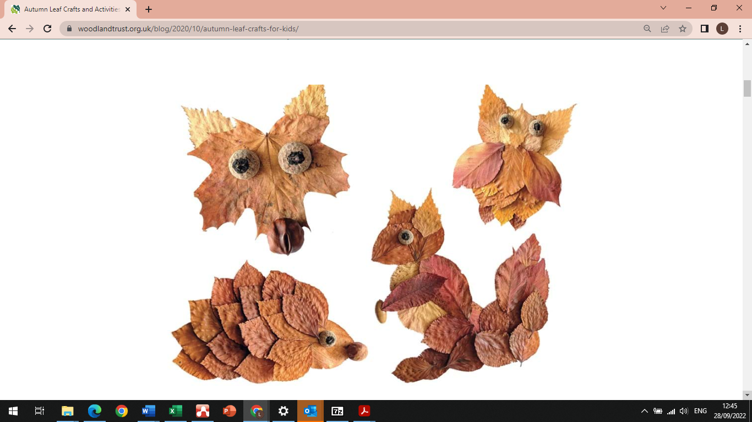

For more ideas, please see: <https://www.woodlandtrust.org.uk/blog/2020/10/autumn-leaf-crafts-for-kids/>

**Does** your child have, or potentially have, an additional need or disability? Pinpoint (www.pinpoint-cambs.org.uk) have lots of information, advice and tips. For Cambridgeshire’s Local Offer go to www.cambridgeshire.gov.uk/residents/children-and-families/local-offer

Education Inclusion Family Advisor Newsletter

October 2022

**Contact me directly on**

** sarah.haddrell@cambridgeshire.gov.uk**