Parent Carer Support Line 

Offers the opportunity to speak to a friendly professional from the E I Family Worker Team about your young person aged 4 to 12 in Cambridge City and surrounding areas.

You can ask question, seek support around behaviour, routines, and boundaries, or just talk about how it is to manage parenting during current times. We will give advice, support, and help with signposting or just listen. You can telephone or email for support any time. Please leave a message with contact details, someone will call you back within 10 working days. We are not an emergency service. Phone 01354 750420 Email- Districtearlyhelpteam.cambridgecity@cambridgeshire.gov.uk



**Activity idea**

**To celebrate international women’s day why don’t you make some cards with the children to send to special women in your lives to make them feel loved and treasured and to know they are important.**



[International Women's Day 2022 (internationalwomensday.com)](https://www.internationalwomensday.com/)

Activity Idea

Ocean breathing (for relaxation)

Have the child lie or sit in a comfortable position. Ask your child to slowly breathe in through their nose, and then out through their pursed lips (as if they are blowing through a straw). Point out that the slow and steady breathing sounds like ocean waves, gently crashing on shore. Let your child continue breathing and making the ocean sound for two minutes.

**Does** your child have, or potentially have, an additional need or disability? Pinpoint (www.pinpoint-cambs.org.uk) have lots of information, advice and tips. For Cambridgeshire’s Local Offer go to www.cambridgeshire.gov.uk/residents/children-and-families/local-offer



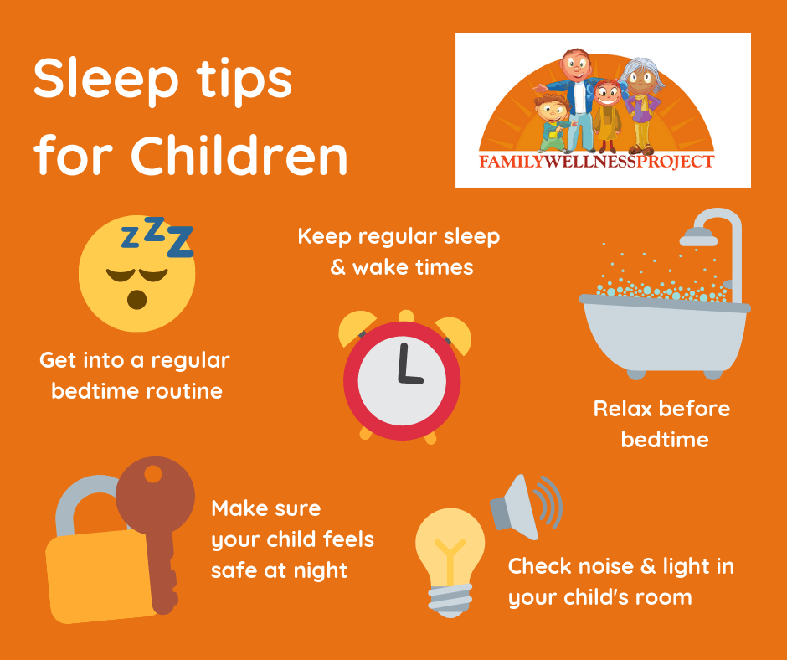



Early Intervention Family Worker Newsletter

7th March 2022