**Community support in Cherry Hinton.**

**Food (free) hub and Community kitchen**

Avoiding food waste in Cherry Hinton * bring a bag

**Where- St Andrew Church**

**When- Wednesday 2-4pm.**

**Activities for children in Cherry Hinton.**

**Messy Play**

Fun for pre-school aged children.

**Where- Baptist Church**

**When- Tuesday mornings 10-12noon.**

**Chirpy Cherries**

Fun for pre-school aged children.

**Where- St Andrews Church**

**When- Friday mornings 9.30-11am**

**52 Stories**

Fun for all children.

**Where- Library**

**When- Saturday mornings 10am**

**Netherhall sports centre**

**Where- Netherhall School**

**When- throughout the week**

**Netherhall.org/sportscentre**

**Activities for young people in Cherry Hinton.**

**Youth group**

**Where- Baptist Church**

**When- Friday**

**From 6.30 7.45pm (school years 4-6)**

**From 7.45-9pm (school years 7-9)**

**Netherhall sports centre**

**Where- Netherhall School**

**When- throughout the week**

**Netherhall.org/sportscentre**

**52 Stories**

Fun for all children.

**Where- Library**

**When- Saturday mornings 10am**

**Welcome to Cherry Hinton**.

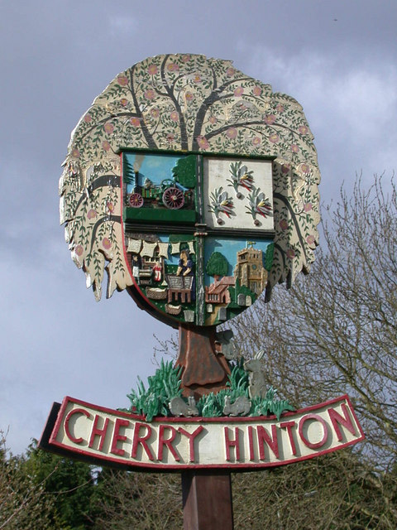

**cherryhintonvillage.co.uk**

**Activities for adults in Cherry Hinton.**

**Community choir**

**Where- Baptist Church**

**When- Monday evenings**

**From 7.30pm**

**Netherhall sports centre**

**Where- Netherhall School**

**When- throughout the week**

**Netherhall.org/sportscentre**

**Fitness activities**

**Where- Cherry hinton village centre**

**When- throughout the week**

**better.org.uk/cherryhinton**



**Supporting children and their families at Cherry Hinton**

**C of E Primary School.**

